Date: 11/20/2022 | Owner: Mary Abia Ediete
Approval Date: | Manager Approval: Yes

BACKGROUND
Jumia is Nigeria’s No 1 online shopping platform, and the current business process operations in Jumia are:
- Customers use the platform to place their orders from across Nigeria.
- Depending on the product's availability, its location, and the delivery location, order processing and delivery can take 3–14 days.
- After placing an order, customers have between 24 and 48 hours to return or exchange items.
- Jumia is currently seeing a decline in its sales performance.

This template provides you with one place to capture the compelling reasons and rationale for why a change needs to happen. Complete this template as part of the Final Project directions.

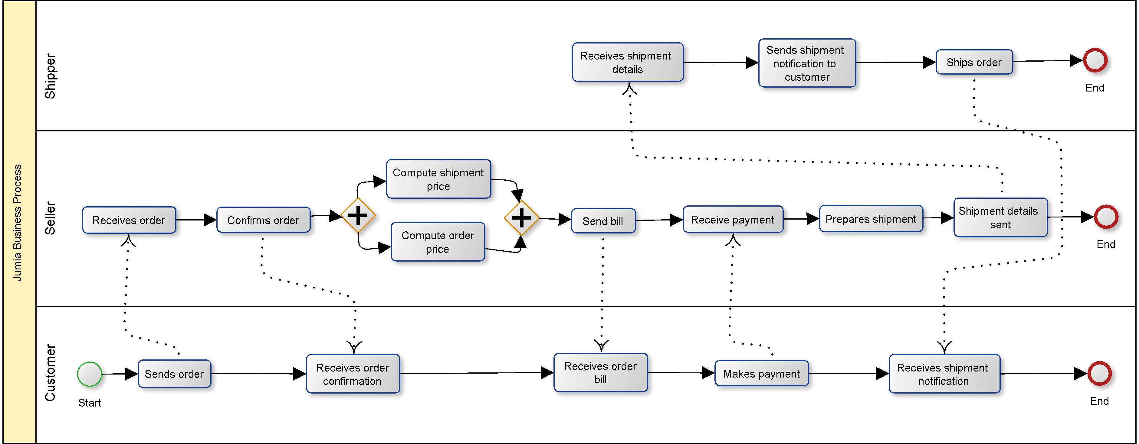

JUMIA’S BUSINESS CASE

By maintaining the manual process at Jumia, the business is facing some problems and its affecting its performance. Jumia is having issues with its performance as a result of continuing to use a manual method. There is currently a problem that has to be fixed regarding the amount of time needed for order processing and delivery. The effectiveness of the sales has declined. Employees are overworked as a result of the amount of orders that must be filled and the manual processes that are utilized to fulfil the orders. Jumia is losing out on opportunities to use technology to streamline order fulfillment and inventory management. One opportunity they are passing on is this one. Because it takes too long to discover orders and additional processes must be taken before the order can be filled, Jumia's manual inventory search approach is ineffective for the company's operations.
Employees at Jumia's retail management division currently spend their days negotiating agreements, planning product promotions, and deciding which products to store in its warehouses and in what quantities and at what pricing. Additionally, they put in days of work fulfilling orders. Order processing requires time due to the manual method used. Employees struggle with managing inventory, finding goods in the warehouse, and even just knowing what things to stock. However, Jumia's management has chosen to employ machine learning to handle the formulaic operations involved in maintaining warehouses stocked because it has access to ten years' worth of retail data.
Jumia's predicament has been carefully examined, and several ways have been suggested to resolve it. Inefficient bookkeeping is second on the list of factors that might harm the firm after slow order fulfillment. No business, no money. No inventory, orders, or business. Jumia will use Fulfillment by Amazon (FBA), one of the special benefits of selling on the Amazon platform, as part of the suggested solution. By using this procedure, retailers may provide Amazon's renowned quick shipping choices in an effort to increase sales. What should sellers do? They utilize the Jumia warehouse to ship and store their merchandise. After that, the fulfillment staff will disperse the merchandise around the nation, figuring out where it could sell best in order to meet your customers' demands for speedy delivery dates. The major drawback? Most likely sales tax. The retailers' dispersed inventory counts as nexus with each state where it is kept, making them suddenly liable for tax collection and payment there. But it's manageable.
Amazon Robotics creates complex equipment and software to increase productivity in Amazon fulfillment centers. As a provider of cutting-edge technologies, Amazon Robotics has long recognized the extraordinary potential gains that can be realized by automating crucial parts of the fulfillment process using artificial intelligence and machine learning (ML). As a result, in 2017, it dedicated teams to achieving just that (Amazon, 2021). According to the A3 Report on the suggested solution, Jumia will first use a small number of automated vehicle guides and RFID tags to assist with inventory organization, management, and also to assist in identifying items bought to aid in order fulfillment. Automating the flow of inventory is made possible by integrating machines and software into the Jumia fulfillment center. Robots bring movable shelving units to stations, where staff members either stash merchandise there or remove it (picking). There are situations when the current stow-and-pick operations can slow down downstream processing. Introducing robots as a project to streamline various operations. By introducing this solution into the ordering processing and fulfilment process it will save Jumia 50% or more in productivity and will increase sales performance and fulfilment performance, thereby making the business top among its industry in Nigeria.

TARGET CONDITION
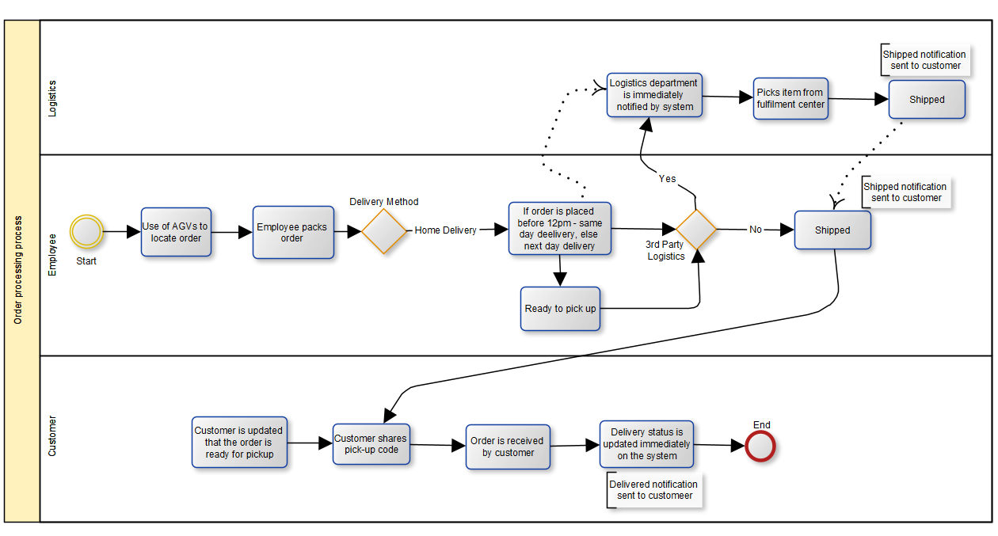

IMPLEMENTATION PLAN
- Introduction of RFID tags and automated vehicle guides (AVGs) in the warehouse
- The launch of the Selling Partner API, which will sync data between retailers and staff to help minimize back-and-forth communication during the order fulfillment process.
- Introduction of automated codes for serialization-based authenticity verification
- The introduction of automated shipping settings

FOLLOW UP
Jumia will set key performance indicators (KPIs) to track the development of the change process to modify the application process. Additionally, information on the effectiveness of the transformation process will be gathered using these KPIs. The information obtained will be used to help decide how to modify the strategy or how to handle other issues that weren't initially thought of. Jumia will also develop an interactive questionnaire to solicit feedback from staff members and candidates on the transition process. The company executives or leaders will use the feedback from the applicants and employees to make more informed decisions.

Audience  Tailor the case to the specific audience. Choose your audience that you will need to communicate the change. Examples:  - CEO  - Board Member  - Project Manager  - Director/Manager  - Employees impacted by the change  - Customers | Provide 3-5 of the most compelling reasons for the change that will resonate with the audience that you have chosen (restate the audience here)
Background  - What current problems need to be solved?  - How did we get here? | - The length of time required for order processing and delivery is a current issue that has to be resolved.  - Jumia wants to upgrade the process flow from manual to automated.  - The sales performance has decreased.  - Due to the volume of orders that must be filled and the manual procedures used to fill the orders, employees are overworked.
Current State  - Where are we now?  - Why is what we’re doing currently not working?  - What opportunities are being missed? | - Jumia is missing out on integrating technology into the business process to assist make inventory management and order fulfillment easy. This is one of the chances they are missing out on.  - Jumia's manual inventory search method is inefficient for the company's operations since it takes too long to find orders and that further steps must be done before the order can be delivered to the client.
Risks of Not Taking Action  - What future problems are anticipated if no action is taken?  - What is the impact to the organization? | - Due to customer annoyance over the prolonged order processing and delivery times, sales have decreased even more and will most likely decrease the more.  - Jumia will have to deal with the market share decline.  - Declining sales will cause the company to lose money and maybe go out of business.  - The workforce is stressed and frustrated with their jobs, which might result in a wave of resignations or a health breakdown from burnout.
Benefits of Taking Action  - What are the benefits of making the change?  - What is the impact to the organization? | - Increase in the company's market share  - Faster order processing and delivery lead to increased sales.  - Enhanced company operations and an improved work environment for the staff  - Increases employee inventiveness and openness to providing fresh ideas to aid the company process.

CURRENT CONDITIONS
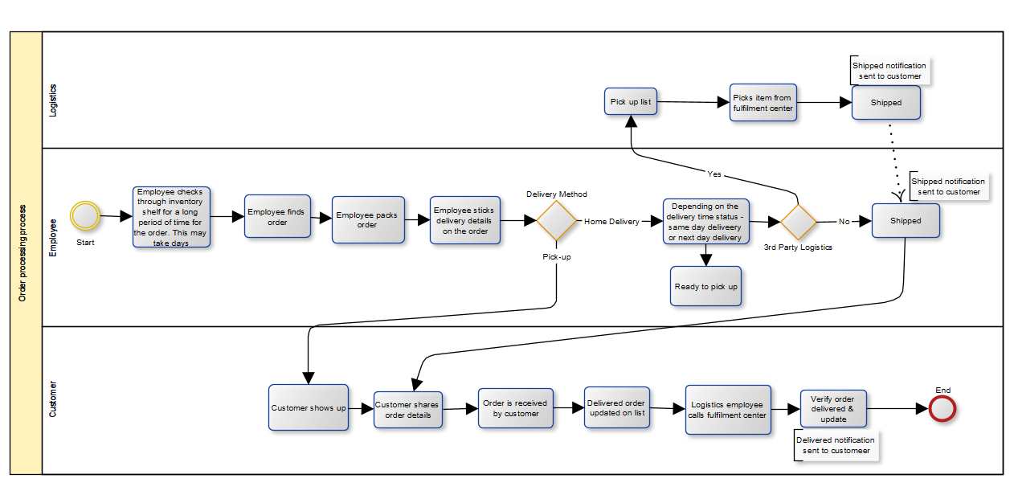

GOAL
- In order to speed up order processing and delivery, the project's goal is to automate the delivery process.
- To use RFID tags and automated vehicle guides (AVGs) in the warehouse in order to organize inventories and make things easier to find.

CAUSE ANALYSIS
The analysis performed to determine the root cause(s)
- Jumia is recording a decline in sales performance
- WHY: Customers are frustrated by the lengthy processing and delivery times for their orders.
- WHY: Customers' orders are delivered over a period of days by the logistics division or a third-party logistics partner.
- WHY: The logistics partner takes more time navigating the locations of the customers, the delivery time is overestimated.
- WHY: For order pickup, the logistics partner is not informed in a timely manner.
- WHY: The warehouse staff takes more time to pack orders and notify the logistics coordinator of them.
- WHY: Employees need more time, sometimes even days, to locate the ordered product.

